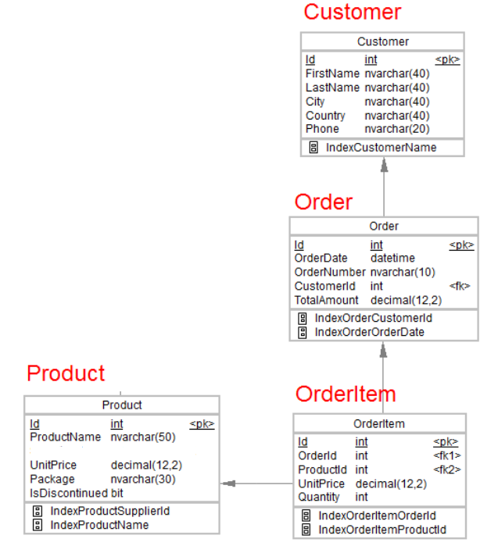

**ASSIGNMENT1**

[2:23 PM] Pagare, Snehal

1.Desgin the above database with following table by applying Primary key and Foreign key

CREATE TABLE Customer

(Id int NOT NULL PRIMARY KEY,

FirstName nvarchar(40) NOT NULL,

LastName nvarchar(40),

City nvarchar(40),

Country nvarchar(40),

Phone nvarchar(20));

CREATE TABLE Orders(

Id int NOT NULL PRIMARY KEY,

OrderDate datetime NOT NULL,

OrderNumber nvarchar(10),

CustomerId int FOREIGN KEY REFERENCES Customer(Id) ,

TotalAmount decimal(12,2));

CREATE TABLE Product(

Id int NOT NULL PRIMARY KEY,

ProductName nvarchar(50),

UnitPrice decimal(12,2),

Package nvarchar(30),

IsDiscontinued bit);

CREATE TABLE OrderItem(

Id int NOT NULL PRIMARY KEY,

OrderID int FOREIGN KEY REFERENCES Orders(Id),

ProductId int FOREIGN KEY REFERENCES Product(Id),

UnitPrice decimal(12,2),

Quantity int);

ALTER TABLE Customer ADD FAX INTEGER;

ALTER TABLE Orders ADD ShipName varchar(50);

alter table Orders add ShippingDate date;

alter table Product ADD supplier varchar(50);

alter table Product ADD CategoryName varchar(50);

CREATE TABLE Employee(

EmpID INT NOT NULL PRIMARY KEY,

EmpRole NVARCHAR(20)

);

alter table Employee Add EmpName nvarchar(50);

alter table Employee Add EmpLName nvarchar(50);

SELECT * FROM Customer;

SELECT * FROM Orders;

SELECT * FROM OrderItem;

select * from Product;

CREATE TABLE Shipping(

ShipName VARCHAR(50) NOT NULL Primary key,

ShipCompany VARCHAR(50) NOT NULL,

IsOperational BIT

);

select * from Employee;

2.Insert Records in all tables

INSERT INTO Customer(Id, FirstName, LastName, City, Country, Phone) VALUES ('1001', 'Rahul', 'Jain', 'Bhopal', 'India', '9876543210'),

('1002', 'Srishti', 'Sharma', 'Berlin', 'Germany', '1234567890'), ('1003', 'Goerge', 'Russel', 'New York', 'America', '2718264850');

INSERT INTO Orders(Id, OrderDate, OrderNumber, CustomerId, TotalAmount) VALUES ('2001', '2018-10-27 12:36:10', '1', '1002', '1500'),

('2002', '2020-05-15 09:07:47', '2', '1003', '3130'), ('2003', '2015-08-27 18:12:33', '3', '1001', '7360');

INSERT INTO Orders(Id, OrderDate, OrderNumber, CustomerId, TotalAmount,ShippingDate) VALUES ('2004', '2018-11-27 12:36:10', '4', '1002', '3000','2022-05-25');

INSERT INTO Orders(Id, OrderDate, OrderNumber, CustomerId, TotalAmount,ShippingDate) VALUES ('2005', '2018-02-25 16:36:10', '5', '1001', '300','2022-05-17');

INSERT INTO Product(Id, ProductName, UnitPrice, Package, IsDiscontinued) VALUES ('3001', 'shampoo', '250.00', '500000', '0'),

('3002', 'cookies', '140.00', '150000', '0'), ('3003', 'cooking oil', '300.00', '683000', '1');

INSERT INTO OrderItem(Id, OrderID, ProductId, UnitPrice, Quantity) VALUES ('4001', '2001', '3001', '250', '200'),

('4002', '2002', '3002', '200', '300'), ('4003', '2003', '3003', '350', '100'),('4004', '2004', '3002', '10', '90'),('4005', '2005', '3001', '17', '80');

insert into Shipping(ShipName,ShipCompany,IsOperational) values ('La corned abondance','AA',1);

insert into Shipping(ShipName,ShipCompany,IsOperational) values ('Titanic','BB',0);

INSERT INTO Employee(EmpID,EmpRole,EmpName,EmpLName) VALUES (101,'Manager','Akshay','Kumar'),(102,'Manager','Rohit','Shetty'),(103,'Employer','Salman','Khan');

3.In Customer table FirstName Attribute should not accept null value

4.In Order table OrderDate should not accept null value

5.Display all customer details

select * from Customer

6.write a query to display Country whose name starts with A or I

select Country from Customer where Country like 'A%' or Country like 'I%';

7 .write a query to display whose name of customer whose third character is i

select FirstName, LastName from Customer

where FirstName like '__i%'

​ **ASSIGNMENT2**

[2:24 PM] Pagare, Snehal

Display the details from Customer table who is from country Germany

select * from Customer

where Country='Germany'

*Display the  full name of the employee

SELECT EmpName + ' ' + EmpLName AS FullName FROM Employee;

*Display the   customer details  who has Fax number

UPDATE Customer SET FAX = 111111 WHERE ID = 1001;

update Orders SET ShippingDate = '2022-12-02' where Id = 2003;

SELECT * FROM Customer WHERE FAX IS NOT NULL;

display the customer details whose name holds second letter as U

select * from Customer

where FirstName like '_u%'

select order Details where unit price is greater than 10 and less than 20

select * from OrderItem where UnitPrice between 10 and 20;

**Display order details which contains shipping date and arrange the order by date

SELECT * FROM Orders WHERE ShippingDate IS NOT NULL ORDER BY ShippingDate DESC;

*Print the orders shipped by ship name 'La corned'abondance' between 2 dates(Choose dates of your choice)

update Orders set ShipName = 'La corned abondance' where Id = 2005;

select * from Orders where ShipName='La corned abondance'and ShippingDate between '2022-01-23' and '2022-05-02';

*Print the products supplied by 'Exotic Liquids'

select * from Product where supplier = 'Exotic Liquids';

print the average quantity ordered for every product

select avg(Quantity) from OrderItem;

Print all the Shipping company name and the ship names if they are operational

SELECT * FROM Shipping WHERE IsOperational = 1;

Print all Employees with Manager Name

SELECT * FROM Employee WHERE EmpRole = 'Manager';

Print the bill for a given order id .bill should contain Productname, Categoryname,price after discount

Select ProductName, CategoryName, Price-(Price*(Discount/100)) AS Bill from Order

Print the Total price of orders which have the products supplied by 'Exotic Liquids' if the price is > 50 and also print it by Shipping company's Name

Select Price, Shiping_Company_Name from order where supplieName is ‘Exotic Liquids’ IIF(Price>50)

**ASSIGNMENT3**

1.write a query to display the orders placed by customer with phone number 030-0074321

SELECT * FROM order_ JOIN customer ON order_.CustomerId = customer.Id WHERE customer.Phone = '030-00743212';

2.  fetching all the products which are available under Category ‘Seafood’.

Select product_name from Product where category=’Seafood’

3.Display the orders placed by customers not in London

SELECT * FROM order_ JOIN customer ON order_.CustomerId = customer.Id WHERE customer.City != 'London';

4. selects all the order which are placed for the product Chai.

SELECT * FROM orderitem JOIN Product ON orderitem.ProductId = Product.Id WHERE Product.ProductName = 'chai';

5.Write a query to display the name , department name and rating  of any given employee

update customer set phone='030-00743212' where Id=1;

insert into Product(Id,ProductName,unitprice,Package,IsDiscontinued,CategoryName,ProductSupplier)Values (116,'Crab cake',300,'READY',1,'Sea Food','Fisheats');

update Product set ProductName='chai' where Id=113;

alter table Employee

add DeptName Varchar(50),

EmpRating int;

update Employee set DeptName='CS' , EmpRating='7'

where EmpId=16;

select * from Employee;

1. Print the Total price of orders which have the products supplied by 'Exotic Liquids' if the price is > 50 and also print it by Shipping company's Name

select sum(unitprice) from Product group by unitprice having unitprice>50;

1. Display the employee details whose joined at first

alter table Employee

add Doj datetime;

update Employee set Doj='2022-02-25'

where EmpId=15;

select TOP 1 * from Employee order by Doj desc;

1. Display the employee details whose joined at recently

select TOP 1 * from Employee order by Doj asc;

**ASSIGNMENT4**

4.     Write a query to get most expense and least expensive Product list (name and unit price).

select ProductName,min(unitprice),max(unitprice) from Product group by ProductName;

1. Display the list of products that are out of stock

alter table Product

add Available varchar(40);

select *from Shipping

update Product set Available ='In stock'

where Id= 116;

select *from Product where Available='out of stock';

1. Display the list of products whose unitinstock is less than unitonorder

Select ProductName from Product where unitinstock < unitinorder;

1. Display list of categories and suppliers who supply products within those categories

select CategoryName , ProductSupplier from Product ;

1. Display complete list of customers, the OrderID and date of any orders they have made

SELECT customer.FirstName,LastName,order_.Id,order_.OrderDate FROM customer JOIN order_ ON customer.Id=order_.CustomerId ;

1. Write  query that determines the customer who has placed the maximum number of orders

SELECT CustomerId, COUNT(Id) AS order_count

FROM order_

GROUP BY CustomerId

ORDER BY order_count DESC;

1. Display the customerid whose name has substring ‘RA’

select customer.Id from customer where FirstName like '%RA%';

1. Display the first word of all the company name

SELECT SUBSTRING(ShipCompany, 1, CHARINDEX(' ', ShipCompany)) AS first_word

FROM Shipping;